

Student name:- Mazin Yaqoob Al Habsi

Student id:- 20f20704

Assignment name:- SQA

Contents

Task 1: Software configuration management activities 3

The activity of software configuration identification 3

The activity of software configuration control 3

Task No 2 4

Task 3: Review of the scope of defect metric 5

Item or product quality measurements 5

Demonstration of defect metric using the example 6

In-process measurements of quality 6

Support quality measurements 6

Task 4: 7

(a) Use of CMM (capability maturity model) in improving the development of software process 7

Maturity levels in the development process 7

(b) Importance of CMM (capability maturity model) in enhancing the quality of software product 8

Components of the capability maturity model 9

1. Levels of maturity 9

2. Development capability 9

3. Key process areas 9

4. Aims 9

5. Common properties 9

References 10

# Task 1: Software configuration management activities

Framework Configuration Management (SCM) is a set of activities that manages change by identifying the things that need to change, establishing relationships between them, creating/portraying instruments for regulating various variations, controlling the changes that are being made in the current structure, and investigating and uncovering/writing about the changes that have been made. Controlling the progressions is critical because if the progressions are not legitimately monitored, they may end up subverting the entire run programming. As a result, SCM is an essential component of all board exercises (Leon, (2015).).

## The activity of software configuration identification

Programming creates identifiable proof for the items to be controlled, creates ID plans for the objects and their forms, and sets up the devices and tactics for collecting and overseeing the controlled things. The following points describe the steps of software configuration activity.

* Identifying the product things to be controlled is one of the first steps in regulating change. Understanding the product set up within the setting of the framework design, choosing programming arrangement substances, evolving a methodology for naming programming items and depicting their connections, and classifying both the standards to be used and the strategy for securing the things are all examples of this.
* Programming design refers to the actual and functional characteristics of equipment or programming as documented in specialized documentation or implemented in a product. It's usually thought of as part of a larger framework design.
* Other SCM activities or assignments, such as programming constructing or breaking down the effect of proposed changes, are influenced by the underlying relationships among the chosen SCIs and their constituent elements. Following these relationships correctly is also important for supporting discernibility. The ID plot for SCIs should be designed with the requirement to plan distinct things into the product structure in mind, as well as the need to aid in the progression of product things and their connections.

## The activity of software configuration control

Controlling changes during the product life cycle is what programming arrangement control is all about. It shelters the procedure of formative what adjustments to make, the expert for endorsing specific alterations, sustenance for putting those changes into action, and the idea of official aberrations from development necessities, as well as abdications of those requirements. The information gained from these activities is useful in estimating change traffic and breakage as part of the redesigning process. The following steps describe this activity (Fahmy, (2020).).

* An element commonly known as a Configuration Control Board is the expert for tolerating or discarding suggested changes (CCB). In smaller projects, rather than a team-oriented board, this specialist may reside with the pioneer or an allocated individual. There can be many stages of progress ability based on a diversity of models—such as the criticality of the item in issue, the concept of the change (for example, sway on budget and plan), or the task's current stage in the life cycle. Depending on these models, the organization of the CCBs used for a certain framework varies (an SCM delegate would forever be available). All partners, according to the CCB's rank, are addressed.
* For commencing change demands, approving the evolution of the change cycle, catching CCB choices, and disclosing change process data, a successful programming change demand (SCR) process necessitates the use of supporting instruments and systems. The following replies for revealed issues can be used with a connection between this instrument's ability and the issue announcing framework.

# Task No 2

Version control, a piece of the time indicated as version control structures, is a method for managing and controlling changes to programming code. Version control structures (VCS) are modifying applications that help programming engineers in controlling assortments to source content all through length. As progress conditions have extended, version control plans have kept up with programming packs in working all the more sharp and speedier. They are unfathomably shuge for Ops packs since they help to decrease creation cycle and cultivate how much raised affiliations. Update control improvement tracks each and every change according to the thing in a particular data base sort. Enduring that a botch is made, fashioners may go through time and separate prior corrections of it like what to help the situation while making unimportant degree of disturbing effect various sidekicks and peers.(Atlassian, 2021).

Change control making PC programs is a best practice for high-performing programming and DevOps social affairs. Structure control other than attracts makers to focus fundamentally more rapidly, allowing programming people to stay aware of speed and sufficiency as the get-together relaxes in size.

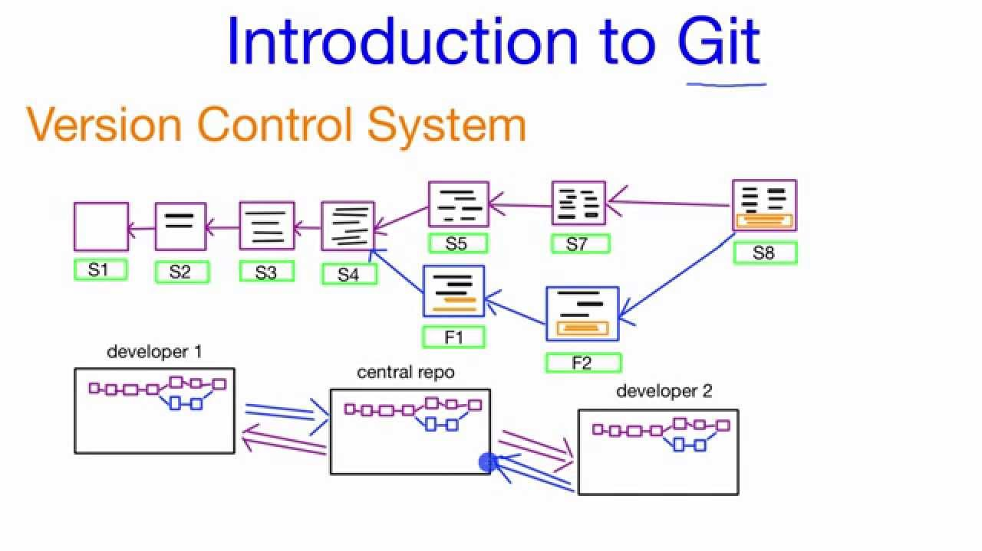

Fig: version control system

Following every novel system to the thing's and attempting to convey it to overseeing tries and thought checking gadgets like Jira, likewise as making saw each change with a remark uncovering the objectives and legitimization behind the change, can help with issue assessment similarly as with both of this public requesting. While investigating the program and understanding what it is doing and why it is shaped the way wherein it is, having the nitty gritty stories of the program open to you might assist designers with making veritable and fit updates that are obvious with the program's somewhat long planning. This is particularly significant while directing old programming, and it is principal in permitting relationship to expect future work with any level of accuracy,(Atlassian, 2021).

**Tool Used for Version Control systems:**

Here I have used GitHub as a Tool for the version Control system.

**Reflection of GitHub as a tool:**

We can easily create a repository over the GitHub. It allows us to review the material and update the data. After each change in the repository, we commit the changes. The changes are updated in the repository no matter what the version of the github is being used. Each record offers an all-out change the technique for history. This joins all progressions made by different people all through the long stretch. Record improvement and destruction, and additionally changes according to their data, are events of corrections. Particular VCS software engineers have fluctuating limits expected to oversee chronicle renaming and improvement. This solicitation should intertwine the innovator, a time period, and comments on why each change was made. Having a total history license, you to absolutely return to past versions to help with issue assessment for issues, which is principal for settling issues with more settled endeavours and programming applications.

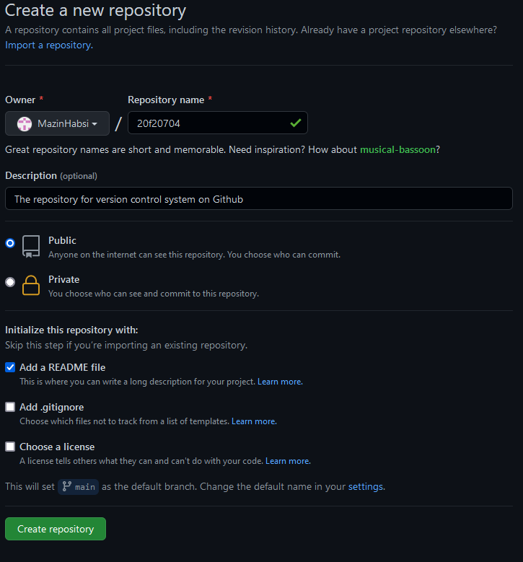

Fig: we can easily create a repository over the GitHub. Here I am creating the repository over the GitHub.

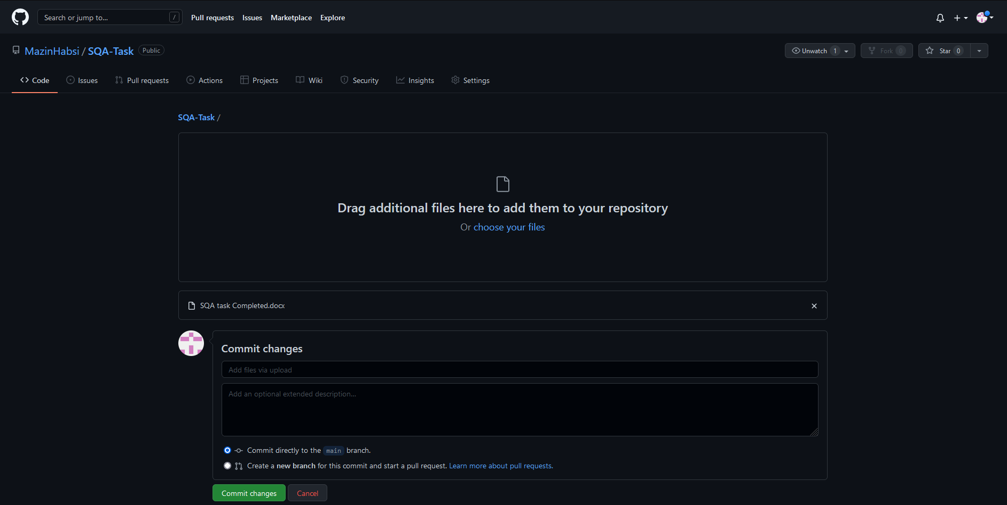

Description: Creating the repository for my assignment over the GitHub.

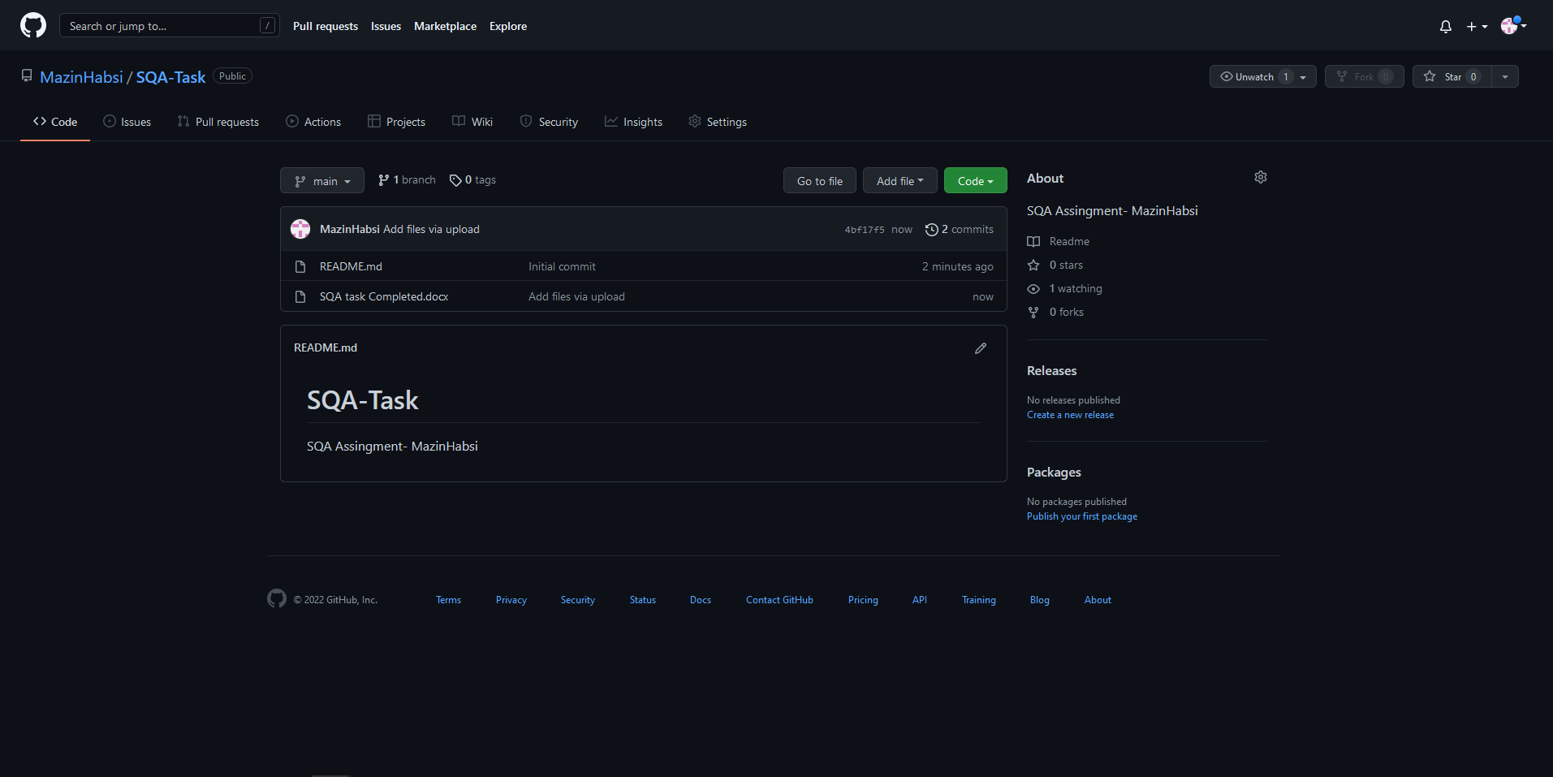

Description: The Task is uploaded over the GitHub.

The Link for the uploaded task is given here.

Link: <https://github.com/MazinHabsi/SQA-Task.git>

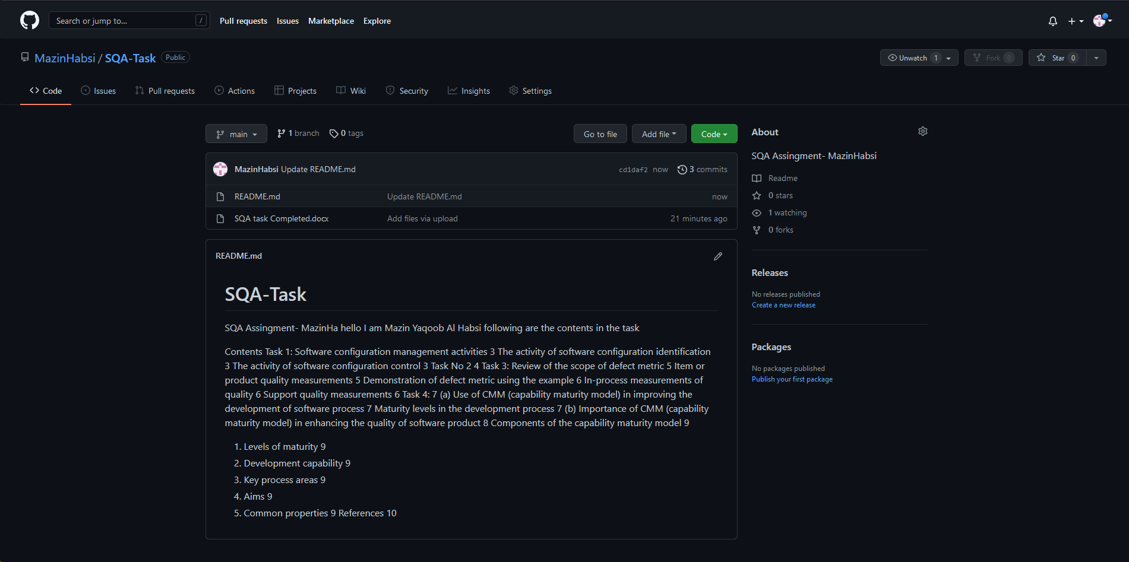

Description: I have added the readme details which show the material of the assignment.

SQA-LAB

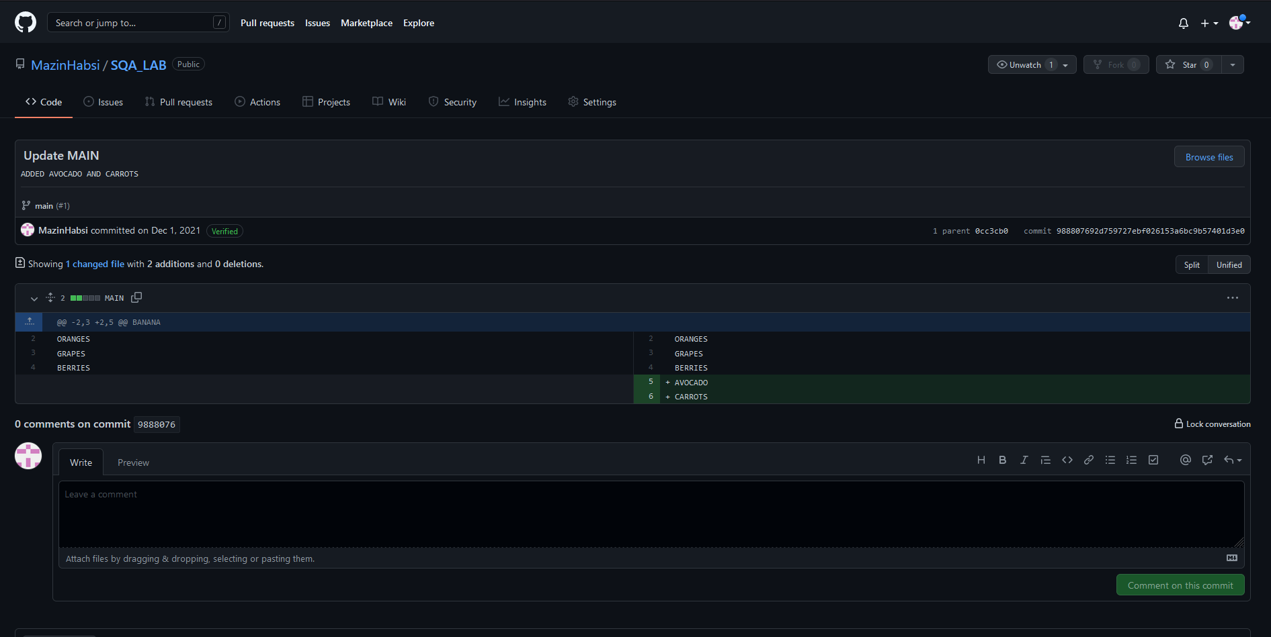

Description: The SQA Lab can be viewed here.

The . main file contains

Link for SQA Lab: <https://github.com/MazinHabsi/SQA_LAB.git>

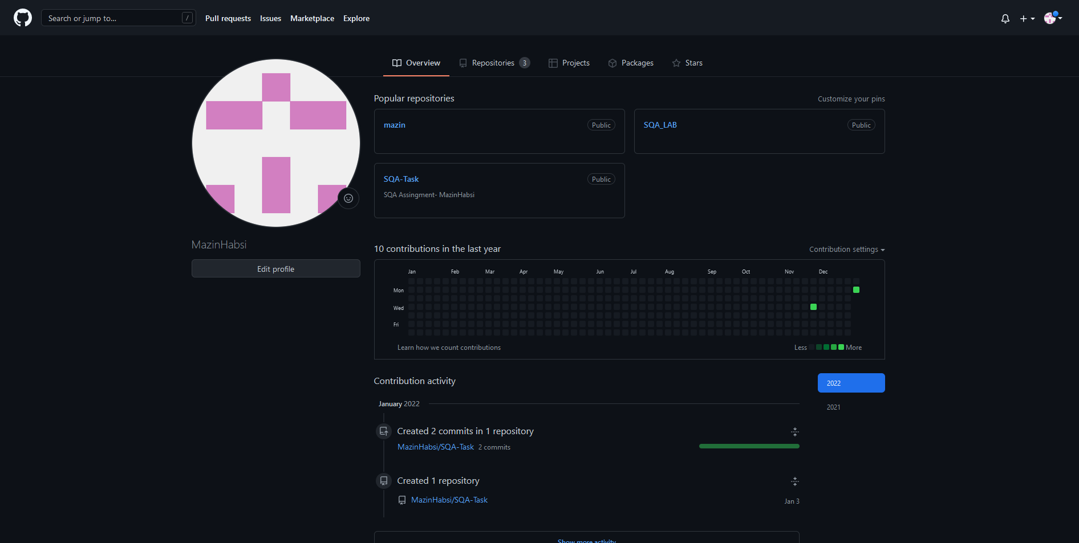

The GitHub Profile

# Task 3: Review of the scope of defect metric

Measurements of quality of programming are a subgroup of measurements of programming that attention to the eminence parts of the product, interaction, and task. These parts are all the more inflexibly associated with the interaction and product dimensions than with project measurements. Programming quality factors can be moreover divided into three classifications (He, (2015). ).

* Measurements of quality product
* In-process measurements of item or product
* Support measurements of the product

## Item or product quality measurements

These measurements integrate the attending.

* Mean Time to Failure
* Imperfection Density
* Client Problems
* Consumer loyalty

## Demonstration of defect metric using the example

It estimates the matters that consumers practice when employing the item. It covers the customer's viewpoint towards the matter space of the artifact, which includes the non-deformity arranged matters along with the imperfection issues (Prasad, (2015).).

The problems or issues of the customers or the clients are measured in terms of problems per client or user month.

PUM = total number of issues that client faces for a particular period + the total number of license months of that software during that age.

Contentment with the common environment of the piece and its specific aspects is normally developed through various policies for shopper reviews. In light of the five-point-scale info, a few dimensions with minor changes can be developed and applied, dependent upon the reason for the investigation. For example:

* Percentage of completely fulfilled consumers
* Percentage of satisfied consumers
* Percentage of dis-fulfilled consumers
* Percentage of non-fulfilled consumers

## In-process measurements of quality

In-process quality extents cope with the following of irregularity appearance during formal machine testing for certain associations. This measurement incorporates.

* Deformity thickness during machine testing
* Deformity appearance design during machine testing
* Stage based deformity expulsion design
* Deformity expulsion adequacy

## Support quality measurements

Albeit much is impossible to change the nature of the item during this stage, coming up next are the fixes that can be completed to dispose of the imperfections as quickly as time permits with amazing fix quality.

* Fix excess and accumulation the board file
* Fix reaction time and fix receptiveness
* Percentage aberrant fixes
* Fix eminence

# Task 4:

# Use of CMM (capability maturity model) in improving the development of software process

The term (CMM) is a process used to generate and perfect an organization or company’s creation advancement procedure. The model depicts a five-level growing way of increasingly coordinated and purposely more experienced cycles. This model was shaped and is progressive by the Software Engineering Institute (SEI), an innovative work community supported by the U.S. Division of Defense (DOD). SEI was recognized in 1984 to solve software design matters and, from an extensive perspective, to boost software design systems (Shen, (2021). ).

## Maturity levels in the development process

* At the underlying stage, processes are disordered, even tempestuous. Accomplishment is perhaps going to depend on individual events and isn't observed as repeatable, because cycles would not be sufficiently considered and archived to permit them to be reproduced.
* At the second stage, an important task is the executive's approaches are set up, and conquests could be repeated, because the authoritative cycles would have been made set up, considered, and archived.
* At the branded level, an organization or company has fostered its customary programming procedure through more projecting pensiveness concerning certification, normalization, and mix.
* At the achieved level, an organization or company shades and panels its cycles through info assortment and examination.
* At the attractive level, processes are continually being worked on through detecting input from present cycles and familiarizing original cycles to good serve the company’s exact necessities.

Fig: levels of CMM

When companies knockout Levels 4 and 5, they are watched as a great development, where they are "ceaselessly proceeding, regulating and emerging to solve the issues of associates and clients." That is the purpose of the CMMI: To find trustworthy circumstances, where objects, managements, and separations are active, proficient, and useful.

# Importance of CMM (capability maturity model) in enhancing the quality of software product

The significance and importance of the capability maturity model can be analyzed by the following points (Gąska, (2017).).

* It guides towards a repeatable standard cycle and thus diminishes the learning time on the most proficient method to finish things.
* Rehearsing CMM implies rehearsing standard convention for the turn of events, which implies it assists the group with saving time as well as gives a reasonable perspective on what to do and what's in store.
* The quality exercises gel well with the venture rather than considered as a different occasion.
* It goes about as a suburbanite between the task and the group.
* CMM endeavors are consistently towards the improvement of the cycle.
* The CMM model is utilized as a standard to enumerate the expansion of a connotation's product cycle.
* It additionally gives rules to additional improve the development of the cycle used to foster those product items.
* It depends on significant input and improvement rehearses taken on by the best associations around the world.
* This model portrays a procedure for programming process improvement that ought to be trailed by traveling through 5 distinct levels.
* It supports the accomplishment of a higher development level at times by dislodging the genuine mission, which is working on the cycle and by and large programming quality.

# Components of the capability maturity model

## Levels of maturity

A growth level is a distinct transformative level to completing an experienced software design process.

## Development capability

Software design process ability portrays the range of expected consequences that can be completed by following a creation cycle.

## Key process areas

Each improvement level is made out of key cycle sections. Each key cycle region knows a group of connected exercises that, when performed altogether, achieve a bunch of purposes considered significant for building up process capacity at that expansion level.

## Aims

The objectives sum up the vital acts of a key cycle region and can be utilized to decide if an association or undertaking has successfully executed the key interaction region.

## Common properties

The normal elements are ascribed that validate whether the execution and systematization of a key interaction area are viable, repeatable, and enduring.

# References

Atlassian. (2021, December 15). *How version control helps high performing development*. Retrieved from Atlassian: https://www.atlassian.com/git/tutorials/what-is-version-control

Fahmy, S. D. ( (2020).). The Evolution of Software Configuration Management. International Journal, 9(1.3).

Gąska, A. H. ( (2017).). Virtual CMM-based model for uncertainty estimation of coordinate measurements performed in industrial conditions. Measurement, 98, 361-371.

He, P. L. ((2015). ). An empirical study on software defect prediction with a simplified metric set. *Information and Software Technology, 59, 170-190.*

Leon, A. ( (2015).). Software configuration management handbook. Artech House.

Prasad, M. C. ( (2015).). A study on software metrics based software defect prediction using data mining and machine learning techniques. . *International Journal of Database Theory and Application, 8(3), 179-190.*

Shen, L. D. ( (2021). ). Capability Maturity Model (CMM) method for assessing the performance of low-carbon city practice. Environmental Impact Assessment Review, 87, 106549.